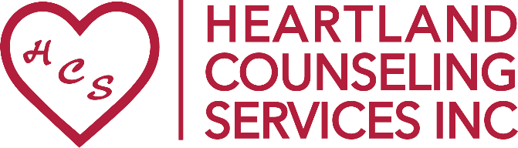

For immediate release: August 30, 2023

For more information: Jennifer Hart, Director of Development
Heartland Counseling Services
C: 978.807.2267 or hart@heartlandcounselingservice.com

Heartland Counseling & Healthy Blue Partner to Raise Awareness of Mental Health Services and Substance Abuse Recovery Month with Walk & Fair!

Heartland Counseling Services and Presenting Sponsor Healthy Blue invite you to join them on September 9th, 2023 for a FREE Mental Health Awareness Walk & Fair at Heartland’s new building in South Sioux City, NE. Families will gather to celebrate the 34th Anniversary for Mental Health and Substance Abuse Recovery Month, walk in memory or honor of loved ones, check out vendor and community service booths, play games and check out fun giveaways, free face painting, bouncy house courtesy of Cholitas Party Rental, enjoy Big Red Tacos food truck, special drawing for Nebraska Cornhusker fans, plus the first 200 attendees will receive a free t-shirts! Festivities run 11am-1pm, with the walk heading out at noon.

This is a FREE, fun event thanks in part to our Stigma Breakin’ Presenting Sponsor: Healthy Blue; Healing Sponsor: Aventure Staffing; Faith Sponsors: Gotcha Covered Siouxland, Cup O’ Joy; Hope Sponsors: Wall of Fame, Cholitas Party Rental, Mutual of America Financial Group, and Pepsi Cola of Siouxland.

“We are so excited to be able to host this event at our new facility and look forward to seeing everyone enjoying our grounds and walking in support of Mental Health!” expressed Executive Director Jennifer Jackson.

The list continues to grow, but current participants include: Wyld Earth n Co selling artwork and doing arts & crafts; Color Street with Deanna Rodriguez; Scentsy with Nicole; Heartland Counseling Services with program information, t-shirts, and selling Kindness Signs; The Life Center with a mindfulness stone project; Project AWARE Grant giving away mental health stickers; Big Brothers Big Sisters with information and fun Big Jenga game; Haven House; Siouxland Pride Alliance; Catholic Charities with program info and PLINKO game; TriState Physicians; Siouxland Community Health Center; Parent Partners; Healthy Blue; Human Rights Commission with Wheel and PLINKO games; Reach Youth & Family Theatre; and the Goodwill of the Great Plains will have their Career Truck on site.

This is a FREE event. If you would also like to become a vendor or sponsor, contact Director of Development Jennifer Hart at hart@heartlandcounselingservices.com or call the office at 402-494-3337 or register/donate online at: www.heartlandcounselingservices.org/walk. Donations received are tax-deductible and help to promote mental health, raise awareness, and support those living with mental illness.

Heartland Counseling is a nonprofit organization providing quality mental health and substance abuse services and education for the tri-state Siouxland community and lives by their motto: “Changing lives. Healing hearts. One day at a time!” For more information on Heartland Counseling Services, how you can receive mental health or substance abuse services, or how you can donate or to help others in their journey to positive mental health, visit www.heartlandcounselingservices.org or call 402-494-3337.

