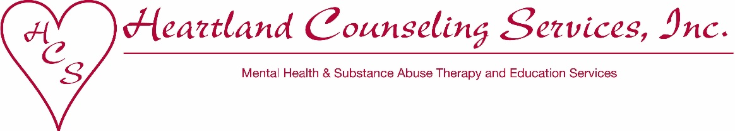

For immediate release: January 7, 2020

For more information: Jennifer Hart, Director of Development
Heartland Counseling Services
402.494.3337 or hart@heartlandcounselingservice.com

Attached Photo:
“F&MBank_HeartlandCounseling_FoodDonation_Dec2019”
left to right in photo: F&M Bank Vice President Nancy Cochrane, Life Center Participant Jolene Hamilton, Heartland Counseling Services Director of Development Jennifer Hart, and F&M Bank Assistant Vice President Jared Noteboom

F&M Bank Food Drive Supports Heartland’s Life Center

Employees and customers at F&M Bank’s three locations in Sioux City and South Sioux City came together to collect food and necessity items for The Life Center at Heartland Counseling Services. The donations came just in time for the Life Center participants gear up for the holidays.

“Giving is not just about making a donation, it’s about making a difference, which is exactly what Heartland’s Life Center does for the Siouxland community,” stated F&M Bank’s Market President Gail Curry. “We are lucky to have some such a great organization in our area.”

The Life Center is a licensed day rehabilitation center serving adults struggling with mental health or substance abuse issues. Participants visit The Life Center Monday through Saturday for a family-style lunch, to do their laundry, take a shower, participate in therapies, nutrition classes, and coping skill groups, and more. The Life Center is a safe place where clients come for support and to learn about successful community living to minimize hospitalizations and homelessness.

“For many, The Life Center is the only ‘family’ left for clients to turn to, to lean on, and to be their support system as they re-learn how to live with their diagnosis,” stated Heartland Counseling Services’ Executive Director Jennifer Jackson. “The Life Center is a life-line to the participants and support from the community is a life-line for Heartland to keep this free program thriving.”

Heartland Counseling Services provides quality mental health and substance abuse services to the Siouxland community. A nonprofit 501(c)3 organization, Heartland’s motto is: “Changing lives. Healing hearts. One day at a time!” To learn more about the many services and programs provided by Heartland Counseling Services or to find out how you can help, contact Director of Development Jennifer Hart at 402-494-3337 x11 or email hart@heartlandcounselingservices.com.

#

